# Danny’s Diner Project – MYSQL

MYSQL

Soniya Shende

**Problem Statement:**

Danny wants to use the data to answer a few simple questions about his customers, especially about their visiting patterns, how much money they’ve spent and also which menu items are their favourite. Having this deeper connection with his customers will help him deliver a better and more personalised experience for his loyal customers.

He plans on using these insights to help him decide whether he should expand the existing customer loyalty program - additionally he needs help to generate some basic datasets so his team can easily inspect the data without needing to use SQL.

Danny has provided you with a sample of his overall customer data due to privacy issues - but he hopes that these examples are enough for you to write fully functioning SQL queries to help him answer his questions!

Danny has shared 3 key datasets for this case study:

* sales
* menu
* members

Let us start by creating the database.

Step 1: Create Database dannys_diner;

Step 2: Now let us create our tables.

1. Sales table: Contains fields like customer_id, order_date and product_id.

CREATE TABLE sales (

customer_id VARCHAR(1),

order_date date,

product_id int

);

1. Menu table: Contains fields such as product_id, product_name and price.

CREATE TABLE menu (

product_id INT,

product_name VARCHAR(10),

price INT

);

1. Members table: Contains fields such as customer_id and join_date.

CREATE TABLE members (

customer_id VARCHAR(1),

join_date DATE

);

Step 3: Inserting values into the tables.

1. Sales table:

INSERT INTO sales

(customer_id, order_date, product_id)

VALUES

('A', '2021-01-01', '1'),

('A', '2021-01-01', '2'),

('A', '2021-01-07', '2'),

('A', '2021-01-10', '3'),

('A', '2021-01-11', '3'),

('A', '2021-01-11', '3'),

('B', '2021-01-01', '2'),

('B', '2021-01-02', '2'),

('B', '2021-01-04', '1'),

('B', '2021-01-11', '1'),

('B', '2021-01-16', '3'),

('B', '2021-02-01', '3'),

('C', '2021-01-01', '3'),

('C', '2021-01-01', '3'),

('C', '2021-01-07', '3');

1. Menu table:

INSERT INTO menu

(product_id, product_name, price)

VALUES

('1', 'sushi', '10'),

('2', 'curry', '15'),

('3', 'ramen', '12');

1. Members table:

INSERT INTO members

(customer_id, join_date)

VALUES

('A', '2021-01-07'),

('B', '2021-01-09');

Questions answered:

1. What is the total amount each customer spent at the restaurant?

SELECT

s.customer_id, SUM(m.price) AS total_spent

FROM

sales s

INNER JOIN

menu m ON s.product_id = m.product_id

GROUP BY s.customer_id;

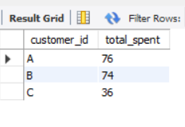

1. How many days has each customer visited the restaurant?

SELECT

customer_id, COUNT(DISTINCT order_date) AS visit_days

FROM

sales

GROUP BY customer_id;

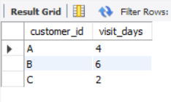

1. What was the first item from the menu purchased by each customer?

WITH CTE AS (

SELECT

s.customer_id,

s.order_date,

m.product_name,

DENSE_RANK() OVER (

PARTITION BY s.customer_id

ORDER BY s.order_date) AS rnk

FROM sales s

INNER JOIN menu m

ON s.product_id = m.product_id

)

SELECT

customer_id,

product_name

FROM CTE

WHERE rnk = 1

GROUP BY customer_id, product_name;

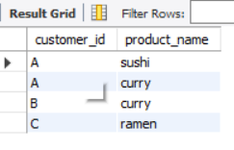

1. What is the most purchased item on the menu and how many times was it purchased by all customers?

SELECT

m.product_name, COUNT(s.product_id) AS most_purchased_item

FROM

sales s

INNER JOIN

menu m ON s.product_id = m.product_id

GROUP BY m.product_name

ORDER BY most_purchased_item DESC

LIMIT 1;

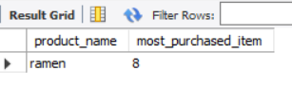

1. Which item was the most popular for each customer?

WITH most_popular AS (

SELECT

s.customer_id,

m.product_name,

COUNT(m.product_id) AS order_count,

DENSE_RANK() OVER (

PARTITION BY s.customer_id

ORDER BY COUNT(s.customer_id) desc ) AS rnk

FROM menu m

INNER JOIN sales s

ON m.product_id = s.product_id

GROUP BY s.customer_id, m.product_name

)

SELECT

customer_id,

product_name,

order_count

FROM most_popular

WHERE rnk = 1;

